Nomination Guide 2026

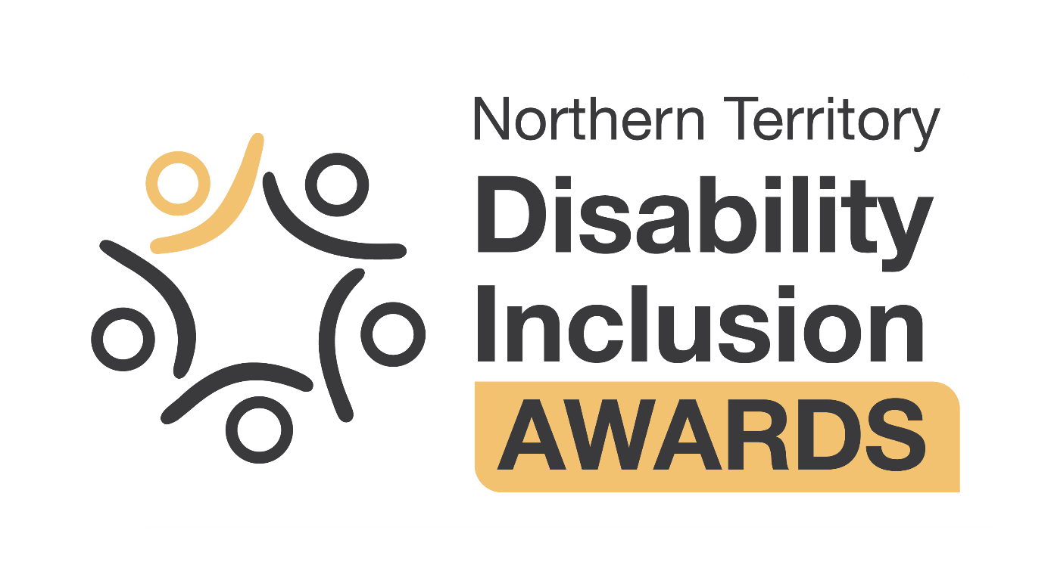

Contents
About the Awards 3
Key dates 3
Nomination process 3
Who can be nominated? 3
What information is required? 3
How to submit a nomination 4
Tips for preparing your nomination 5
Assessment process 5
Eligibility 5
Judging 6
Event ceremony 7
Contact 7
Award categories 8
Excellence in Rights Promotion and Empowerment 8
Excellence in Innovation 9
Inclusive Communities Award 10
Excellence in Service Provision 11
Excellence in Support 12
Excellence in Education and Employment 13
Terms and conditions 14

About the Awards
The Northern Territory Disability Inclusion Awards (the Awards) recognise people and organisations making a real difference in the lives of Territorians with disability.
Now in its 16th year, the Awards highlight inclusion in action – from innovation and leadership to community participation, employment and outstanding achievements in the disability sector.
The Awards are coordinated by the Office of Disability in the Department of People, Sport and Culture (the Department), on behalf of the Northern Territory Government.
Everyone has a role to play – government, business and the community. The Awards bring this to life by recognising the people and organisations leading the way.
For more information including a list of previous winners, visit Northern Territory Disability Inclusion Awards.

Key dates
Awards stage | Date
Nominations open | 8 May 2026
Nominations close | Sunday 28 June 2026
Finalists announced | August 2026
Award ceremony | Friday 25 September 2026

Nomination process
You can nominate an individual, team, organisation or business, and entry is free. Nominate Now

Who can be nominated?
Nominees must:
- be a resident of the Northern Territory or provide place-based services to people in the Northern Territory
- have been employed in their current role or in operation for at least 6 months; and
- have undertaken the work for which they are nominated after 1 January 2025.

What information is required?
Nominations
All nominations must address the category specific nomination questions outlined in the Nomination Form (maximum of 250 words per question).
In addition, a short summary statement of up to 25 words (2-3 sentences) is required to highlight the nominee’s achievements and impacts made. This statement will be used for media purposes and onstage presentations if the nominee is selected as a finalist.
Incomplete nominations will not be considered and will be deemed ineligible.
Referee
All nominations require contact details for an external referee.
The referee is someone who can endorse your nomination and provide a comment about their experience with the nominated individual, team, organisation or business.
Please advise the referee that they will be contacted in relation to the nomination and seek clarification as to how they wish to be contacted, either by phone or email.
Before submitting a nomination, make sure that you have all the information required. Make sure all phone numbers or email addresses are correct.
Supporting information
You may want to provide supporting information for your nomination.
Supporting information is not mandatory however provides an opportunity for the achievements and outcomes described in the nomination to be supported.
Supporting information must be emailed to OfficeofDisability.DPSC@nt.gov.au. You can submit up to 5 files. The total size of all attachments must not exceed 20 MB.
These could include but are not limited to:
- Written testimonies
- Video or audio testimonies
- Photos of activities or initiatives that show work or impact
- Digital works (website, blog, video, etc)
- Finalist or winner certificate from another awards program
- Evaluation or survey results
- News stories
File size and type guidelines:
- Written documents | - Videos or audio | - Photos
- Word or PDF document  - Max 500 words | - Max 2 minutes  - MP4 or link to YouTube | - JPEG or PNG file formats  - Require a caption

How to submit a nomination
Complete the online Nomination Form by Sunday 28 June 2026.
- The form may take up to 30 minutes to complete.
- You must complete the form in one sitting.
- Ensure you have read the nomination questions and have supporting materials ready.
Alternative ways to nominate:
- Printable nomination form - complete and email to OfficeofDisability.DPSC@nt.gov.au.
- Other formats such as video and audio files or in person nominations will also be accepted. Contact OfficeofDisability.DPSC@nt.gov.au to arrange.
You must submit your nomination by Sunday 28 June 2026.

Tips for preparing your nomination
- Make sure you have the following information ready before you begin:
  - Nominee details.
  - Contact details for a referee to support your nomination.
  - Information and examples that address the award nomination questions set out later in this document.
  - Any supporting information you wish to include, such as written testimonials, photographs of an activity or a news story.
- Make sure all details provided in the Nomination Form, including nominee and referee contact details, are entered accurately.
  - The Office of Disability is not obligated to follow up any information that is incorrect, including contact details and if unable to contact nominees and/or referees, nominations will be unable to progress.
- Respond to all nomination questions thoroughly, clearly showing how the nominee has made a positive difference in the lives of people with disability.
  - Explain the outstanding work or achievements clearly and succinctly.
  - Be specific about the nominee’s work – is it related to a specific project or initiative? Is the work continuing or now complete? What timeframes apply? What were the major outcomes? What impact did it have on the disability community?
  - Explain how the achievements have made a tangible difference to the lives of people with disability, their families or carers.
  - Support your claims relating to the nominee’s attributes or qualities with examples that will be easily understood by the judging panel – avoid jargon.
  - Stick to the word limit and keep answers concise and to the point. Either full sentences or dot points are acceptable. Avoid repeating examples.
- Submit your nomination first, then email all supporting documents to OfficeofDisability.DPSC@nt.gov.au
  - Supporting documents are used to verify information provided in the Nomination Form.
  - Make sure all files are within the guideline size and can be easily opened.
- Submit your nomination before the closing date on Sunday 28 June 2026.

Assessment process

Eligibility
Acceptance of nomination
All nominees will be contacted after the nominations period closes to seek their consent for their nomination to progress.
- If a team is being nominated, all team members must agree to be nominated.
- If an organisation or business is being nominated, the organisation’s Chief Executive Officer or similar must agree to the nomination.
Additional information including the category they have been nominated for, the process if they are selected as a finalist and the terms and conditions of the nomination will be provided.
Nominees who consent, agree to associated media publicity and promotion associated with the Awards, including the use of photos submitted, or taken at the Awards presentation ceremony to be used in accordance with the Terms and conditions outlined below.
Initial Screening
All nominations will be reviewed to ensure they meet the eligibility criteria and align with the relevant award category.

This includes:
- Residence/continued connection to community.
- Length of time in current role/operation.
- Work has occurred since 1 January 2025.

The Office of Disability will only request additional information from a nominator/nominee where clarification is required or to conduct a governance check.

Governance checks
Eligible nominations will undergo governance checks to confirm if there is any unprofessional conduct that may require the nomination to be withdrawn.

The Office of Disability may:
- research whether the nominee is under investigation or subject to an order of any relevant regulatory body or enforcement agency;
- contact the nominee’s employer/organisation to verify nomination details, this may include direct contact with the nominee’s employer, manager or direct supervisor; and/or
- request alternative validation, such as references or testimonials from colleagues or industry representatives if required.

A nomination will be withdrawn if a nominee is found to have a record of unprofessional conduct.

Judging
All eligible nominations are reviewed by an independent Judging Panel (the Panel). The Office of Disability will provide Secretariat support and will not participate in the assessment process.
The assessment process is confidential, and all decisions made by the Panel are final. Neither the Panel nor the chair is required to provide feedback to nominees or nominators.
The Panel is to be made up of people with disability and lived experience of disability, key professionals and subject matter experts in accordance with the Panel Terms of Reference. In addition, a representative from each category sponsor organisation will be invited to participate as a partner judge for their sponsored category.
Judges will evaluate each nomination based on the information provided in the nomination.
Shortlisting
Panel members will evaluate and individually rank nominations to shortlist up to 4 finalists for each category. The Secretariat will collate rankings and not enter any correspondence or provide individual feedback regarding shortlisting or nomination details.
Once shortlisting is complete, finalists will be contacted directly by the Office of Disability to advise of their progress.
- Finalists should be available and endeavour to attend the event ceremony (inability to attend does not disqualify nomination).
- Finalists will be requested to provide a clear image of themselves, noting the image will be used on promotional material such as social media and visual presentation at the ceremony.
Referees will be contacted to seek verification and endorsement of each finalist’s nomination.
Finalists will be officially announced on the Awards webpage and through the Department Facebook page.
Judging Day
The Panel will convene formally to assess and discuss the finalist nominations in detail and determine winners and, if appropriate, any highly commended nominations.
The winner of the Overall Award for Excellence will be the highest scoring nomination across all categories.
The Secretariat will provide administrative support as required, to ensure appropriate documentation of processes and outcomes.

Event ceremony
Award winners will be announced at the event ceremony hosted by the Hon Jinson Charls MLA, Minister for Disability at Parliament House on Friday 25 September 2026.
The ceremony will feature live captioning and Auslan interpreting on the night, and a livestream will be available for those unable to attend in person.
All finalists will be invited to attend the ceremony, accompanied by a carer or support person if required.
- Finalists living in regional or remote areas may be able to access a travel and accommodation subsidy. All other costs to travel and attend the ceremony are to be covered by the finalist.
- Finalists may be asked to prerecord a video message should they be unable to attend the ceremony in person.
After the ceremony, winners will be published on the Awards webpage and promoted on the Department Facebook page.

Contact
For more information including an Easy Read fact sheet, visit https://dpsc.nt.gov.au/ntdia.

Office of Disability:
Phone: 08 8999 2809
Email: OfficeofDisability.DPSC@nt.gov.au
Address: 356-366 Bagot Road, Millner NT 0810
Postal Address: GPO Box 3970, Darwin NT 0801

Award categories
There are 6 award categories and an Overall Award for Excellence selected from the pool of individual category winners.
The award categories align to the Northern Territory Disability Strategy 2022–2032, which sets a shared direction for building a more inclusive Territory.
Learn more about the Strategy.

Excellence in Rights Promotion and Empowerment
This Award recognises an individual, team, organisation or business that has made a significant contribution supporting and promoting the human rights of people with disability, empowering choice and control, independence and decision-making capacity.
It celebrates efforts that challenge barriers, advance inclusion, and enable people with disability to more actively participate in decisions that affect their lives or communities.
Nominees may have contributed through advocacy, leadership, policy influence, education, community development, or initiatives that promote a rights-based approach to elevate the voices and lived experiences of people with disability.
Nomination Questions
- How has the nominee promoted and protected the rights, dignity, and equality of people with disability?
- How has the nominee demonstrated leadership in advancing disability rights, inclusion, or social change?
- How has the nominee empowered people with disability to understand their rights, make decisions, and advocate for themselves?
- How has the nominee created opportunities for people with disability to influence policies, services, or community decisions?
- What impact has the nominee’s work had on people with disability, their families, carers, or the broader community?


This award is proudly sponsored by the Northern Territory Public Guardian and Trustee.

Excellence in Innovation
This Award recognises an individual, team, organisation or business that has developed new or innovative approaches to ensuring people with disability can access services, facilities or information. The innovation may be groundbreaking or help people with disability overcome barriers or solve complex challenges.
It celebrates creativity and forward-thinking that addresses inequalities, improves accessibility, or creates new opportunities for people with disability to participate in their community with greater independence. Impactful innovations are designed in collaboration with people with disability.
Nominees may have demonstrated innovative work developing and implementing new service models, accessible housing, public spaces, transport, technology, products that enhance independence, or inclusive communications.

Nomination Questions
- How has the nominee introduced innovative solutions or approaches that enable greater access, participation, and independence of people with disability?
- What key features make this work innovative?
- How does the innovation respond to a challenge being experienced by people with disability?
- What positive impact has this innovation had on the lives of people with disability, their families and carers?
- Please explain how people with disability were involved in shaping the innovation. For example, through co-design, consultation, or feedback.

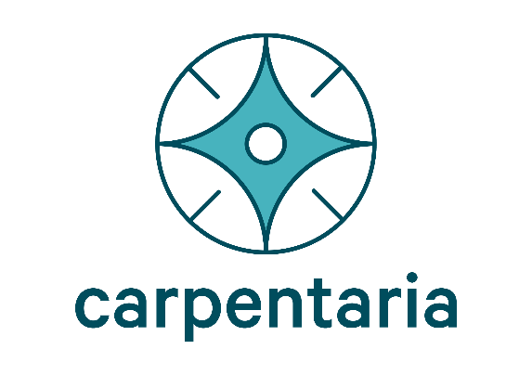
This award is proudly sponsored by Carpentaria Disability Services Inc.

Inclusive Communities Award
This Award recognises an individual, team, business or organisation that has made a significant contribution to improving participation and inclusion of people with disability, their families and carers within the community.
It celebrates impactful inclusivity that is achieved through collaboration with people with disability, raising awareness and significantly improving access and integration across all aspects of community life, from public spaces, workplaces, and education, to events, services, and social activities.
Nominees may have demonstrated inclusivity by adapting services, programs, or approaches to promote inclusion and participation for all, or by actively enabling access to social, recreational, sporting, arts, cultural, or community activities.

Nomination Questions
- How is the nominee creating greater opportunity for people with disability to access and participate in the community, fostering independence, and enhancing social connections?
- What mainstream services or aspects of community life have been impacted the most?
- How is the nominee promoting understanding, respect, and positive attitudes from the broader community?
- How impactful has the nominee’s work been on people with disability, their families, carers, or the wider community?
- How has the nominee actively involved people with disability in planning, decision-making, or leadership?


This award is proudly sponsored by Sommerville Community Services Inc.

Excellence in Service Provision
This Award recognises the significant contribution of a disability sector organisation in providing supports, services and opportunities that are over and above best practice.
It highlights organisations leading the way and providing impactful services that are person-centred and respond to the diverse needs of the community.
Nominees may provide services in the following areas, but are not limited to:
- in-home supports that assist people with disability and their families to live independently and with dignity.
- therapy or capacity-building supports that help people with disability to develop skills and achieve their goals.

Nomination Questions
- What services, programs, or supports does the organisation provide for people with disability in the Northern Territory and what needs do they address?
- How has the organisation been a leader or made an outstanding contribution to the disability sector and what meaningful impact has it made?
- How does the organisation go over and above to support people with disability to build skills, independence, and exercise choice and control?
- How does the organisation ensure the services it delivers are safe, respectful, and responsive to individual needs? What are its safeguard policies and practices?
- How are people with disability involved in guiding practice, service expectations and outcomes? This could be through co-design of quality frameworks, processes or systems, or people with disability holding leadership and/or governance positions.

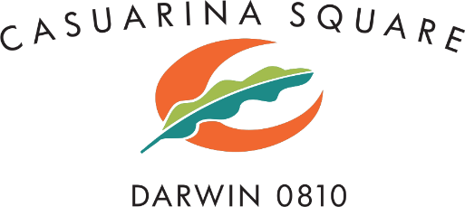
This award is proudly sponsored by Casuarina Square Shopping Centre.

Excellence in Support
This Award recognises the outstanding contribution of an individual in providing disability supports, services and opportunities over and above the needs of the people with disability they support.
It celebrates someone who demonstrates dedication, compassion, and skill in providing person-centred support and highlights the difference one person can make in fostering independence and supporting people with disability to live the life they choose.
Nominees may provide support in the following areas, but are not limited to:
- in-home supports that assist people with disability and their families to live independently and with dignity.
- therapy or capacity-building supports that help people with disability to develop skills and achieve their goals.

Nomination Questions
- What role does the nominee play in supporting people with disability and in what setting? For example in the community, workplace, family, or service setting.
- How does the nominee support people with disability to exercise choice and control in their lives?
- Provide examples of how they actively involve people with disability in decisions about their support and services, including goal-setting.
- Provide examples of how their support has improved independence, wellbeing, participation, or inclusion.
- How do they adapt services, approaches, or activities to meet the unique needs of the people they support?


This award is proudly sponsored by HPA Incorporated.

Excellence in Education and Employment
This Award recognises an outstanding individual, team, organisation or business that employs or supports people with disability to access education, training, or employment opportunities.
It celebrates the significant work and continued commitment of the nominees in creating meaningful pathways for people with disability to learn, develop skills, and participate fully in school, vocational training, or the workplace, empowering them to thrive.
Nominees may have demonstrated excellence in the following areas, but are not limited to:
- Supporting people with disability to gain, maintain, or progress in employment.
- Making workplaces more inclusive, accessible, and welcoming.
- Helping people with disability access education, training, or skill-building opportunities.
- Acting as a mentor, coach, or role model to support learning, growth, and development.

Nomination Questions
- What role does the nominee play in supporting people with disability in education, training, or employment?
- How does the nominee help people with disability to access and thrive in their chosen education, training, or employment setting?
- Provide examples of tailored supports, reasonable adjustments, or initiatives that have promoted inclusive, welcoming environments that encourage and support participation.
- How does the nominee demonstrate innovation, creativity, or best practice in education or employment supports for people with disability?
- What measurable or observable positive outcomes have been achieved for people with disability? For example, increased participation, employment retention, skill development, or personal growth.


This award is proudly sponsored by the Office of the Commissioner for Public Employment.

Terms and conditions
Definitions
- “Awards” refers to the 2026 Northern Territory Disability Inclusion Awards.
- “Department” refers to the Department of People, Sport and Culture in the Northern Territory Government.
- “Nominator” is the person who completes the Nomination Form and recommends that the nominee is considered for an award.
- “Nominee” is the person to be considered for an award.
- “Office of Disability” is a work unit of the Department.
- “Partner” means a sponsor or partner of the Awards with a formal partnership arrangement with the Department.
The Awards
- The Department takes no responsibility for nominations that are lost, delayed, or misdirected.
- All nominations must be received by the closing date. Late nominations, or amendments to a nomination, may only be accepted with prior written consent from the Department.
- The Department will not provide any nominator with feedback on their nomination.
- Entries may be withdrawn by the nominator or at the request of the nominee at any time during the nomination and judging process by contacting the Department.
- The selection of nominees, finalists and winners reflects the nominations received and information available to the Department and the judges at the time. The Department reserves the right to withdraw a nomination or Award if further information or the nominees’ conduct draws the Awards into disrepute.
- Nominators and/or nominees must notify the Department immediately if conduct that may draw the Awards into disrepute occurs or there is a change of circumstance that may require the nomination to be withdrawn.
- The Department reserves the right to amend Award categories or criteria if appropriate.
- The Department reserves the right to cancel the Awards in the event of, but not limited to tampering, unauthorised intervention, fraud, or any other causes beyond its control, which corrupt or affect the Awards’ security, fairness or integrity or proper conduct of the Awards.
- The Department reserves the right in its sole discretion to disqualify any individual who tampers with the entry process, and/or cancel the awarding of the prize.
- The Department shall not be liable for any loss or damage whatsoever which is suffered, (including but not limited to) direct or consequential loss or for any personal injury suffered or sustained in connection with any prize, except for any liability which cannot be excluded by law.
- General photos or images of attendees taken at the Awards ceremony, including those taken by the official photographer, may be used by the Department for publicity and promotional purposes. Should an attendee wish for their photo not to be taken, they should approach a staff member at the event ceremony or contact the Office of Disability to advise prior.
Nominations
- Nominees are only eligible to be nominated once per category.
- Nominees are eligible for nomination for more than 1 category, however, may only win 1 category (not including the Overall Award for Excellence).
- Previous winners are not eligible for nomination for the same category they have already won for a period of 2 years.
- Previous finalists for any Award category are eligible for nomination again for the same category.
- Managers and team leaders are eligible to nominate their teams for an applicable category. This is not considered a self-nomination.
- Multiple teams from a single organisation may be nominated for the same category, provided that the team’s name and team members are not the same, or the initiative or work being nominated is not the same.
- Government employees and teams are eligible to be nominated, however, strict conflict of interest processes will apply to maintain integrity of the Awards.
- Nominations will not be accepted from:
  - the nominee themselves (self-nomination)
  - family members of the nominee
  - employees of the Partner organisation nominating for the sponsored category
  - employees of the Office of Disability
  - members of the Judging Panel.
- All nominees must agree to be nominated. The Department will contact all nominees to confirm their acceptance of the nomination. Nominees reserve the right to decline participation.
- Supporting information will be used to verify information provided in the nomination. All submitted materials will become the property of the Office of Disability and will not be returned.
- The Office of Disability will not provide any nominator with specific feedback on their nomination.
- Late submissions will not be accepted and extensions cannot be granted after the nomination closing date.
Eligibility and governance checks
- Nominees must meet the following eligibility criteria:
- be a resident of the Northern Territory or provide place-based services to people in the Northern Territory;
- have been employed in their current role or in operation for at least 6 months; and
- have undertaken the work for which they are nominated after 1 January 2025.
- All nominations will be screened to ensure eligibility against the eligibility criteria and Awards terms and conditions.
- Further information will only be sought from nominators/nominees to conduct necessary governance checks or if clarification is needed.
- All eligible nominations will have a governance check conducted by the Department. This may include direct contact with the nominee’s employer, manager or line supervisor to confirm the nominee is eligible and that there is no information that may require the nomination to be withdrawn.
- Nominees must have demonstrated professional conduct and have:
- no conditions, undertakings, limitations, or notations on their professional or service provider registration;
- not be under performance management (for individual nominations only); and
- have no formal complaints lodged regarding inappropriate behaviour in the workplace (for individual nominations only).
Judging
- The selection process is confidential. Feedback will not be provided.
- The Judging Panel will be an independent group of people who are appointed in accordance with the Panel Terms of Reference and at the Department’s discretion.
- The Panel will determine finalists and the winner of each Award Category and if appropriate any highly commended nominations.
- Each nomination will be assessed based solely on the information provided in the nomination.
- Judges are required to declare any real or perceived conflict of interest and withdraw from assessing any nomination where they are associated in any way with the nominator, nominee, nominated team, organisation or business.
- The decision of the Panel is final and cannot be appealed.
- If a nomination has been received that is better suited to a different Award category, the Panel may consider the nomination in that category. The nominator and nominee will be notified if this is the case.
Information and privacy policy
- The Department respects and is committed to safeguarding the confidentiality and privacy of the information it collects and handles, in accordance with the Northern Territory Information Act 2002.
- There are strict rules for how your information is collected, handled and managed. For more information on privacy, go to the Office of the Information Commissioner website.
- The Department collects data and information in the Nomination Form for the purposes of determining eligibility and assessing nominations for the Awards. Your data will only be used for the purpose outlined and will not be used for any other purposes.
- You do not have to provide your personal information but if you choose not to, the Department will be unable to accept your nomination.
- The nominee name, organisation and position title may be published on the Department website if deemed a finalist or winner.
- Information that is both personal and sensitive should not be provided.
- The information you provide will be accessible to the Department and the Awards independent Judging Panel members and will only be used to deliver the 2026 Awards. We will not disclose your personal information to third parties unless:
  - authorised or required by law to do so
  - you have given us your consent to share your personal information for a specific purpose.
- You may request access to the personal information we hold about you by contacting the Department of Corporate and Digital Development (DCDD) Freedom of Information unit on 08 8999 1793 or foi@nt.gov.au.
- For online nominations only: Data will be captured and stored on Microsoft servers located in the USA.
- By submitting a nomination, you agree to these Terms and conditions including this Information and privacy policy.

