Following approval from LANT Government Archives for the transfer of the records, certain conditions must be met before physical transfer can take place. The agency is required to box and list the records on the Series Consignment List for each consignment and prepare a Series Registration form and Access Agreement form for each new series. Contact LANT Government Archives at LANT.NTGArchives@nt.gov.au for specific instructions concerning preparation of your consignments.
General guidelines for packing of boxes and common records such as files are provided below. Specific advice should be obtained from LANT Government Archives before preparation starts to avoid having to reprocess the records. Instructions can be provided on the preparation of non-standard record formats, such as volumes, bundles, tubes, magnetic tape or film reels, maps or plans, index cards, glass plate or film negatives, and microform. Records showing signs of mould, insect, water or other damage must be identified and isolated. Contact LANT Government Archives for advice on treating the records before transfer.

How do I pack my records for transfer
Records being transferred in boxes or other storage containers must be packed appropriately to ensure they are not in danger of long-term physical damage and to ensure that they can be easily removed from and returned to the container without physical damage.
Boxes must not be over-packed. Approximately five cm of space must be left so that files can be removed and replaced without damage. Boxes must shut properly and not bulge at the sides. If a box will not shut properly or is bulging at the sides, it is over packed. Boxes must not be under-packed, as files and volumes can bend and lose shape. Box lids must not be taped shut.
Bulldog clips, paperclips and other metal fasteners and elastic bands must be removed from records (staples and split pin file fasteners are acceptable). Contact the LANT Government Archives for advice on fasteners that will be accepted
Adhesive tape must not be used on records, either to repair or adhere documents within a file. Adhesives are detrimental to paper long term and do not retain adhesion over time. If adhesive tape is found on records while preparing them for transfer, do not attempt to remove it. Do not laminate documents.
Post-it notes must be removed - if the information on the post-it note is important to the file, photocopy it and place the photocopy on the file.
Records stored in lever arch folders or metal binders must be removed from the folders, placed into file covers or manila folders, secured with tube-clips or white cotton tape, and labelled appropriately (including file part numbers if necessary). If there is any relevant information recorded on the front or spine of the lever arch folder or binder (e.g. file titles, date range, control numbers, etc.), photocopy that information and place the photocopy in the front of the new file/s.
Documents must be secured to the file - ideally documents should be secured to a file using a plastic tube-clip; in the absence of a tube-clip use another type of file fastener (that is not metal, adhesive, or rubber) or tie the file with archival ribbon/white legal tape
Newspaper clippings or documents printed on thermal papers (e.g. fax paper) must be photocopied and the photocopy included in the file. Newspaper will become very brittle and discoloured over time. The writing on thermal papers will fade and be unreadable over time.
Files and records must be placed in boxes from front to back and packed in the same sequential (file number) order in which they were created and maintained.
Front
Back
Files must face in the same direction with numbers visible to allow for easy retrieval.
The spines of files should be at the bottom of the box unless they are uneven due to a bulky file pin end and thinner at the base. It is advisable then to pack half the files with the spine at the bottom of the box and half the files with the spine at the top of the box to evenly distribute the files within each box.
Documents stored on USB sticks, CDs, and DVDs that are part of the file must be printed and placed on the file. If the contents of these storage mediums are not documents, but other types of digital records, contact the LANT Government Archives for specific advice.

Which boxes do I need?
Records for transfer must be packed in standard Type 1 (T1) archives boxes. T1 boxes measure 370mm x 170mm x 250mm and are the most common box used since they take standard files. If you have records in a format that cannot be accommodated in this box type contact LANT Government Archives.
Self-locking archives boxes are supplied disassembled. The inside of the box will have fold creases. Instructions for the assembly of Type 1 box are below:
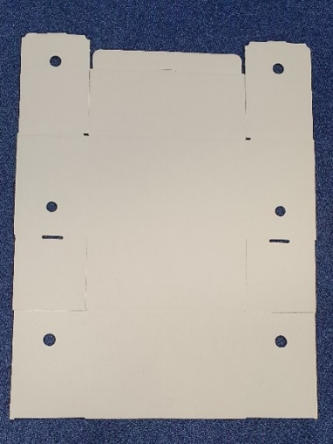  1. | 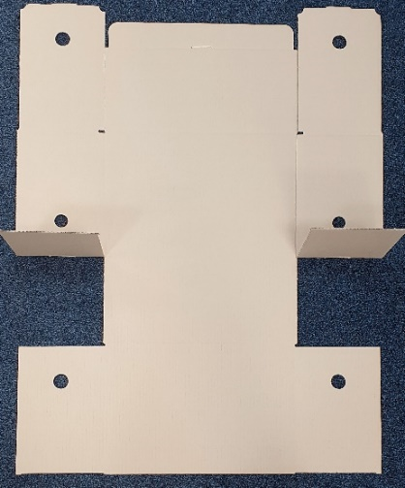  2.
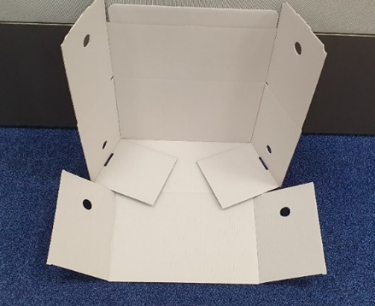  3. | 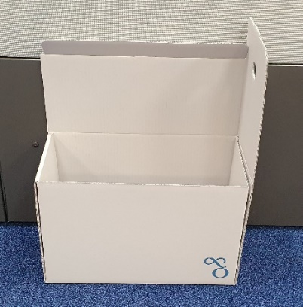  4.

The box number must be pencilled in on the front face of the box. There is no need to write the number of each file in the box on the outside of the box as this is recorded on the Series Consignment List. All writing on the box is to be in pencil only. Boxes that are marked with permanent marker, liquid paper, with crossing out, sticky labels or sticky tape will not be accepted. Writing must only be on the area indicated by the white space on the diagrams below
The box will receive an adhesive label identifying the relevant details for its control and retrieval when it is processed by Government Archives. Only clean skin boxes, inside closing boxes will be accepted.
Pencil box number
Acid free box
Non-acid free box

Once the records have been registered by the Archives Service, Archives One box labels will be provided to the agency. Labels should be placed over the printed space on the box as above prior to scheduling the delivery of the transfer. If in doubt about where to position the labels, please contact the Archives Service.

Where do I buy boxes for transfers
Type 1 (T1) standard archives boxes are available in an acid free box or non-acid free box. The LANT Government Archives preference is to receive records transferred in acid free archives boxes. Acid free archives boxes can be purchased from archival supply companies such as Archival Survival (NAA Range Type 1) or Conservation Resources (NAA Type 1 box).
Non-archival Type 1 boxes can only be purchased under the NTG D19-0050 Records Management Services from the following suppliers:
- Iron Mountain (Records Box, NTAS unbranded carton - Internal Lid, 370mm x 170mm x 250mm)
- Grace Information Management (C3 clean skin small archive carton, 370mmLx170mmWx250mmD)
For the purchase of archives boxes in Alice Springs contact
NTG Across Government Contracts (Department of Corporate and Digital Development)
Email: across.governmentcontracts@nt.gov.au
Phone: 8999 1729

Further help and advice
Further information can also be located on the LANT Government Archives transfer procedures website.

