 | - Questions are followed by answer fields. Use the ‘Tab’ key to navigate through. Replace Y/N or Yes/No fields with your answer.
Once your information is released interstate, the protection of your personal information cannot be absolutely guaranteed.
Under the Information Act 2002, the Department of Territory Families, Housing and Communities cannot supply your personal information to anyone without your consent.
If you wish to consent to the release of information to a particular person or organisation please complete and sign this form.
Fields marked with an asterisk (*) are required.
Fields marked with a caret (^) are for office use only.
Applicant details
Title* (Mr/Mrs/Miss/Ms/Other)
Surname* |  |  |  |  | Given names*
Telephone A/H* |  |  |  |  | Telephone B/H*
Fax* |  |  |  |  | Email address*
Address*
Preferred contact method* (Phone/Mail/Email/Fax)
This authorisation is valid from the date of my signature on the reverse of this form and relates to single disclosure valid for 30 calendar days.
Advocate or agency details
Advocate or agency name*
Relationship
Telephone A/H* |  |  |  |  | Telephone B/H*
Email address*
Specific information to be provided*
Please attach additional pages if more space required
Client authorisation
I, (name) *
authorise the release of the information described in section 2 to the person(s) or organisation named on this form. I understand that:
- information will only be disclosed to the advocate or agent I have nominated to act in my interests for the nominated period on the front of this form
- my personal information will be treated in a confidential manner in accordance with the Information Privacy Principles at schedule two of the Information Act 2002
- I can withdraw this consent at any time.
Signature* |  |  |  |  | Date*
The Department of Territory Families, Housing and Communities only collects personal information which is necessary for the performance of its operations and provision of services. If you do not provide the information requested, we may not be able to assist you. The department will not release your personal information to a third party without your consent or unless it is required or authorised by law in accordance with the provisions of the Information Act 2002 and Information Privacy Principles at schedule two. You have a right to access and correct any information held relating to you by the department.
Office use only^
Information released? ^ |  |  | Yes ☐ No☐ |  |  | Release date^
Releases by (name and position)^
Signature^
Once complete, place this form on the client’s group file – For Housing place a note on TMS.
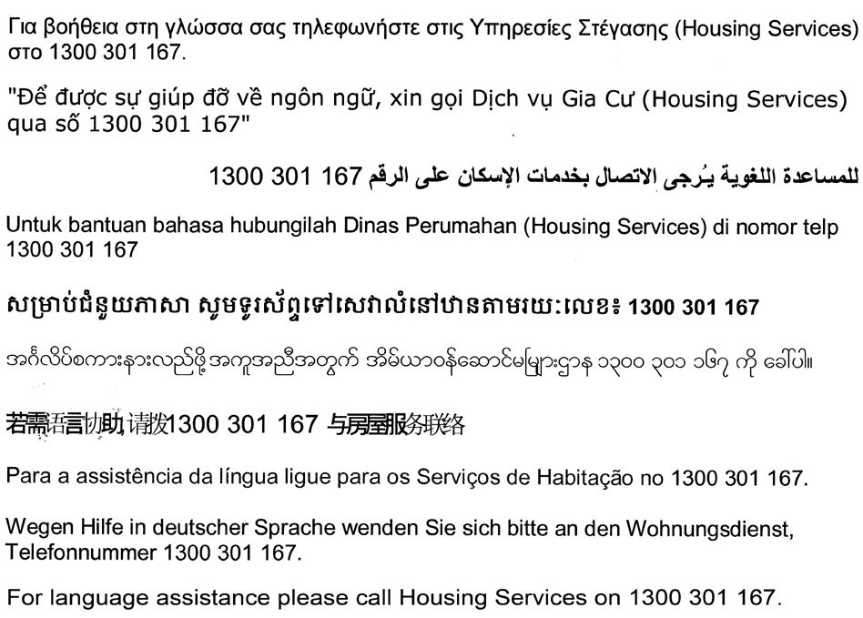

Assistance:
If you require assistance with completing this application please contact Freedom of Information by:
Telephone: (08) 8999 8490
Fax: (08) 8942 6806
Correspondence: PO Box 37037, WINNELLIE NT 0820
Email: TFHC.InfoAccess@nt.gov.au

