Northern Territory Youth Round Table 2027 Application Form
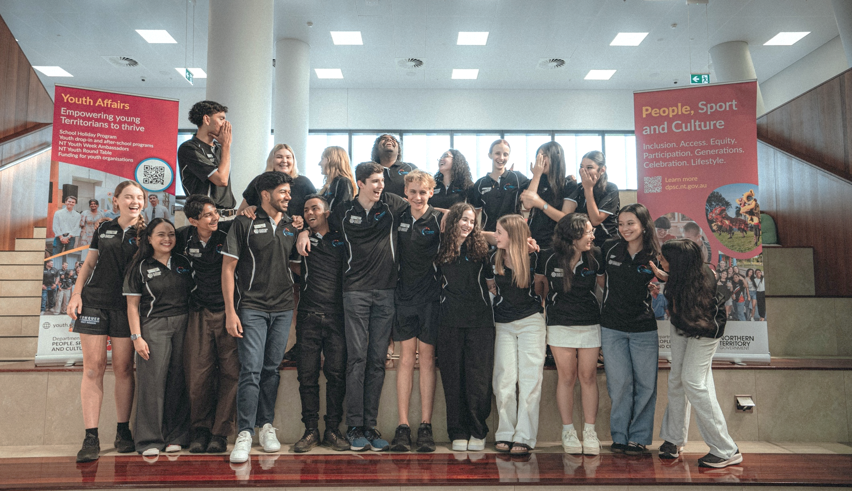
  - 2027 Application Form

About the NT Youth Round Table
The Northern Territory (NT) Youth Round Table (Round Table) program gives young Territorians aged 15 to 25 a platform to speak up and be heard on matters important to them!
Congratulations on taking the first step in applying to join the NT Youth Round Table!
For 30 years, the Youth Round Table has provided over 450 young Territorians with the opportunity to develop their leadership skills, advocate for young Territorians on issues of importance, and consult with Northern Territory Government ministers and senior executives.
The next Youth Round Table member could be you!
We receive an astounding number of applications each year, and this is step one in the application process (the form!). If you are feeling overwhelmed or unsure about answering the form, please feel free to call or text us (0484 240 264) or email us (DPSC.OYA@nt.gov.au) so that we can support you.
Once you complete the form and email it to us at DPSC.OYA@nt.gov.au, your application is reviewed by the Office of Youth Affairs (we run the program - learn more about us at youth.nt.gov.au). If we are impressed with your application, we will invite you for an in-person or online interview at a time that suits you.
After the interview process, it may take a few weeks for us to get back to you about whether you have been successful or not. If you have any questions while you're waiting, please contact us!
***
Please note that by completing and submitting this application, you are providing personal information to the Northern Territory Government's Office of Youth Affairs (OYA), for the purpose of applying to be a part of the 2027 NT Youth Round Table.
Without your personal information, OYA would be unable to process your application for the 2026 NT Youth Round Table. OYA will use the information you provide on this form to determine your suitability for a position in the 2026 NT Youth Round Table.
The Office of Youth Affairs takes the protection of your personal information very seriously. We collect personal information and protect your privacy in accordance with the provision of the Information Privacy Principles found at Schedule 2 of the Information Act 2002. Your information will only be used for the purpose it was collected and will not be disclosed to a third party unless you have provided your informed consent or if it is required by law. For further information, please contact the Freedom of Information unit by emailing DCF.LegalServices@nt.gov.au.
Applications close 11.59pm ACST on 18 October 2026.

Note: * indicates mandatory fields.

Personal details
Title |  |  |  | Given name *
Family name * |  |  |  |  |  |  |  | Preferred name
Date of birth * |  |  |  | Gender * |  |  |  |  |  |  |  |  |  | Pronouns
Residential address *
Suburb * |  |  |  | State/Territory * |  |  |  |  |  |  |  |  |  | Postcode *
Is your postal address the same as your residential address? If not, please include here. *
Which region of the Northern Territory do you represent? * |  |  |  |  |  | ☐ Darwin  ☐ Palmerston and Rural  ☐ Big Rivers |  |  |  |  |  |  |  |  | ☐ Barkly  ☐ East Arnhem  ☐ Central Australia
Email address * |  |  |  |  |  |  |  |  |  | Contact number *
If under 18 years old, please provide a name and contact details of a parent/guardian.
Please provide the full name, phone number, and email address.
Are you an Australian citizen/permanent resident? * |  |  |  |  | ☐ Yes  ☐ No | How long have you lived in the NT?
Are you of Aboriginal and/or Torres Strait Islander descent? * |  |  |  |  | ☐ Yes  ☐ No | What is your cultural background?
Is English your first language? If not, what is your first language? * |  |  |  |  | ☐ Yes  ☐ No – my first language is ________________________
Do you identify as having a disability or mental health condition? |  |  |  |  | ☐ Yes  ☐ No | If yes, are there any ways in which we can support you in making your program experience more accessible?
Education and employment
Current study * |  |  |  |  | ☐ Senior school  ☐ VET/TAFE |  |  |  |  |  |  |  | ☐ University  ☐ Not studying
 |  |  |  |  | Other (please indicate)
Name of School/Institute/University (if applicable)
Year level (school) or stage of course (e.g. 2nd year out of 4 year course)
Course (if applicable)
Current employment * |  |  |  |  | ☐ Not currently working  ☐ Full-time |  |  |  |  |  |  |  | ☐ Part-time  ☐ Casual
 |  |  |  |  | Other (please indicate)
Role and Organisation (if applicable)
About you
Tell us about yourself (your likes, passions, hobbies etc.) (Please limit your response to 150 words) *
Describe how you work in a team environment. What qualities do you bring to the group? Provide examples of where you worked effectively in a similar situation. (Please limit your response to 150 words) *
Please list your involvement in community activities, programs or organisations you support/volunteer with. (Please include organisation/event details, your roles and responsibilities, and years active.)
NT Youth Round Table
The NT Youth Round Table provides an opportunity for young people to have their views heard by government. Members consult and advise various government departments, community groups and other organisations on key initiatives and strategies throughout their 12-month term.
Why do you want to join the NT Youth Round Table? What skills or experience do you bring to the role? (Please limit your response to 150 words) *
What do you hope to gain from the NT Youth Round Table program? What skills would you like to develop? (Please limit your response to 150 words) *
Time Management and Commitment
The 2026 NT Youth Round Table members will need to be available for the following meetings: Four in-person meetings in Darwin; and six online videoconferences (monthly).

In-person meetings will require you to stay overnight at the accommodation (one night for local members, three to four nights for members from regional areas, depending on flight availability).
Tentative schedule: February (online), March (in-person), April (online), May (online), June (in-person), July (online), August (online), September (in-person), October/November (online), December (in-person).
Are you able to attend the four in-person meetings and monthly online videoconferences? * |  |  |  |  |  |  |  |  |  |  |  |  |  |  |  |  |  |  | ☐ Yes  ☐ No
How do you make time for your commitments, and how would the Youth Round Table fit into your schedule? *
Northern Territory Youth Strategy 2023-2033
The Northern Territory Government is committed to ensuring young people in the Territory are safe, healthy and happy, and given the opportunity to thrive. We aim to empower young Territorians and give them the tools and skills to be the driver of their future.
The Youth Strategy aims to address the needs of young people in the Territory to lead enjoyable lives, and be celebrated, socially connected and active participants in their community. The Strategy’s 3-year Action Plan sets out actions and practical steps to be taken to guide and strengthen the Northern Territory Government’s investment and effort in program and service responses in the area of youth. Read the NT Youth Strategy and Action Plan here.
Based on the Strategy’s Domains, Priorities and Outcomes, what do you think we should prioritise for the next 3 years? *
How could you, as a young person, contribute to following these priorities? *
What do you identify as the three most important issues for young people in the Northern Territory? *
(Please select three options)
☐ Mental health  ☐ Diverse range of activities  ☐ Alcohol and other drugs |  |  | ☐ Safe spaces for young people  ☐ Employment opportunities  ☐ Domestic, family and sexual violence |  |  |  |  |  |  |  | ☐ Environment and climate change  ☐ Education  ☐ Crime and anti-social behaviour
Other (please specify)
How would you make sure that your views, and the views of young people in your community, are put forward to the Government as part of the NT Youth Round Table? *
References
Please provide us with details of a referee/community member that can support your application. This person may also be contacted about your application and could be a teacher, community member, person you have worked with etc.
Referee’s name * |  |  |  |  |  |  | Position/  organisation *
Relationship * |  |  |  |  |  |  | Contact number *
Email address *
Other
How did you hear about the NT Youth Round Table? (Please tick all that apply)
☐ Youth NT website  ☐ Social media  ☐ School/university  ☐ Poster/flyer |  |  |  |  |  |  |  |  | ☐ Family/friend referral  ☐ Youth worker/organisation referral  ☐ Word of mouth
Other (please specify)
Which social media platforms are you familiar with using? If you are selected for an interview, you may be required to accept the Office of Youth Affairs into your social media platforms. Participation in the NT Youth Round Table program will require you to contribute towards Youth NT social media platforms to develop stories and posts.
☐ Facebook  ☐ Instagram |  |  |  |  |  |  |  |  | ☐ WhatsApp  ☐ LinkedIn
Other (please specify)
Over to you!
Is there anything else you would like us to know?

Section 9: Consent and Signature
I consent to the reasonable disclosure by the Office of Youth Affairs of the following information about me:
- I confirm that the information I have provided in this application is true and correct to the best of my knowledge.
- I acknowledge that the NT Youth Round Table is a drug-and-alcohol-free program, and if successful in being recruited to the program, I will not consume drugs or alcohol while I am involved in related activities.
- I agree that if successful, I will be available to attend all NT Youth Round Table meetings in 2027.
- I give permission for the release of information as outlined.
Applicant to sign and if under 18 years, must have signature from parent or guardian.
Name *
Signature * |  | Date *
Parent/Guardian Name (applies only if applicant is under 18 years) *
Signature * |  | Date *
Section 11: Submission
For more information about the NT Youth Round Table, visit youth.nt.gov.au. If you have any queries, contact the Office of Youth Affairs on (08) 8999 3862 or email dpsc.oya@nt.gov.au.

Completed applications should be submitted to the Office of Youth Affairs by 11:59pm on 18 October 2026 via:
- Email: dpsc.oya@nt.gov.au
- Post: NT Youth Round Table Coordinator, Office of Youth Affairs, Department of People, Sport and Culture, GPO Box 3970, Darwin NT 0801.
- Hand Delivery: NT Youth Round Table Coordinator, Office of Youth Affairs, Department of People, Sport and Culture, Level 1, Building JHV2, Jape Homemaker Village, 356 Bagot Road, Millner NT 0810.

