Before you fill out the form
This form is used to submit a nomination for the 2026 Northern Territory Disability Inclusion Awards, with six award categories open for nominations. Nominations close on Sunday 28 June 2026.
Before starting, refer to the 2026 Nomination Guide for information about the awards, the nomination process, preparation tips, and the terms and conditions.
This form takes up to 30 minutes to complete. Ensure you have nominee details, referee contact details, information and examples that address the award nomination questions set out in the Nomination Guide, and any supporting information ready.
Once completed, email the form and supporting documents to OfficeofDisability.DPSC@nt.gov.au.
Fields marked with an asterisk (*) are required.

Part A – Nominator and Nominee details
Your details (Nominator)
Mr / Ms / Mrs / Mx / Miss / Master / Other:
First name: * |  |  |  |  |  |  | Surname: *
Employer/ organisation: *
Position/role: *
Phone/mobile: * |  |  |  |  |  |  | Email: *
Where do you live? *  Check the NT Government's regions map for more detail. |  |  |  | ☐ Greater Darwin, Palmerston and Litchfield  ☐ Top End  ☐ Big Rivers  ☐ Interstate |  |  |  |  |  |  | ☐ East Arnhem  ☐ Central Australia  ☐ Barkly
How did you hear about the Awards? |  |  |  | ☐ Social Media  ☐ Radio  ☐ Television  ☐ Other: __________________________________ |  |  |  |  |  |  | ☐ Service Provider  ☐ Advocacy organisation
Demographics  Do you identify yourself as any of the following? Select all that apply. |  |  |  | ☐ Aboriginal or Torres Strait Islander  ☐ Culturally and linguistically diverse  ☐ Person with disability  ☐ Carer |  |  |  |  |  |  | ☐ LGBTQIASB+  ☐ Senior (over 50yrs)  ☐ Youth (under 26yrs)
Relationship to nominee: *

Nominee details
If your nomination is for a team, business or organisation, please provide:
Name of organisation/team nominated:
For all nominations, please provide:
Mr / Ms / Mrs / Miss / Master / Other:
First name: * |  |  |  |  |  |  |  | Surname: *
Preferred name:
Employer/organisation: *
Position/role: *
How long has the nominee been in their position: *
Phone/mobile: *
Email*
Region of primary residence*  Check the NT Government's regions map for more detail. |  |  |  |  | ☐ Greater Darwin, Palmerston and Litchfield  ☐ Top End  ☐ Big Rivers  ☐ Interstate (see below) |  |  |  |  |  | ☐ East Arnhem  ☐ Central Australia  ☐ Barkly
If the Nominee resides interstate, please provide a summary of their continued connection to the Northern Territory community.
How long has the nominee lived in the Northern Territory? *
Demographics  Does the nominee identify as any of the following? Select all that are known to apply. |  |  |  |  | ☐ Aboriginal or Torres Strait Islander  ☐ Culturally and linguistically diverse  ☐ Person with disability  ☐ Carer |  |  |  |  |  | ☐ LGBTQIASB+  ☐ Senior (over 50yrs)  ☐ Youth (under 26yrs)

Part B – Award categories
There are 6 individual award categories.
Please complete only the relevant section in Part B.
Select the category your nomination is for:
☐ | Excellence in Rights Promotion and Empowerment | - Proceed to Section B-1
☐ | Excellence in Innovation | - Proceed to Section B-2
☐ | Inclusive Communities Award | - Proceed to Section B-3
☐ | Excellence in Service Provision | - Proceed to Section B-4
☐ | Excellence in Support | - Proceed to Section B-5
☐ | Excellence in Education and Employment | - Proceed to Section B-6

B-1 | Excellence in Rights Promotion and Empowerment

Award overview
This Award recognises an individual, team, organisation or business that has made a significant contribution supporting and promoting the human rights of people with disability, empowering choice and control, independence and decision-making capacity.
It celebrates efforts that challenge barriers, advance inclusion, and enable people with disability to more actively participate in decisions that affect their lives or communities.
Nominees may have contributed through advocacy, leadership, policy influence, education, community development, or initiatives that promote a rights-based approach to elevate the voices and lived experiences of people with disability.
This award is proudly sponsored by the Northern Territory Public Guardian and Trustee.


Nomination questions
How has the nominee promoted and protected the rights, dignity, and equality of people with disability? *
Please write no more than 250 words.
How has the nominee demonstrated leadership in advancing disability rights, inclusion, or social change? *
Please write no more than 250 words.
How has the nominee empowered people with disability to understand their rights, make decisions, and advocate for themselves? *
Please write no more than 250 words.
How has the nominee created opportunities for people with disability to influence policies, services, or community decisions? *
Please write no more than 250 words.
What impact has the nominee’s work had on people with disability, their families, carers, or the broader community? *
Please write no more than 250 words.
Is there anything else you would like us to know about the nominee that supports your nomination? *
Please write no more than 250 words.
In 25 words (2-3 sentences), please summarise your nomination, highlighting achievements and impacts made. *
The summary will be used for all media purposes and onstage presentation at the Awards ceremony.

B-2 | Excellence in Innovation

Award overview
This Award recognises an individual, team, organisation or business that has developed new or innovative approaches to ensuring people with disability can access services, facilities or information. The innovation may be groundbreaking or help people with disability overcome barriers or solve complex challenges.
It celebrates creativity and forward-thinking that addresses inequalities, improves accessibility, or creates new opportunities for people with disability to participate in their community with greater independence. Impactful innovations are designed in collaboration with people with disability.
Nominees may have demonstrated innovative work developing and implementing new service models, accessible housing, public spaces, transport, technology, products that enhance independence, or inclusive communications.

This award is proudly sponsored by Carpentaria Disability Services Inc.
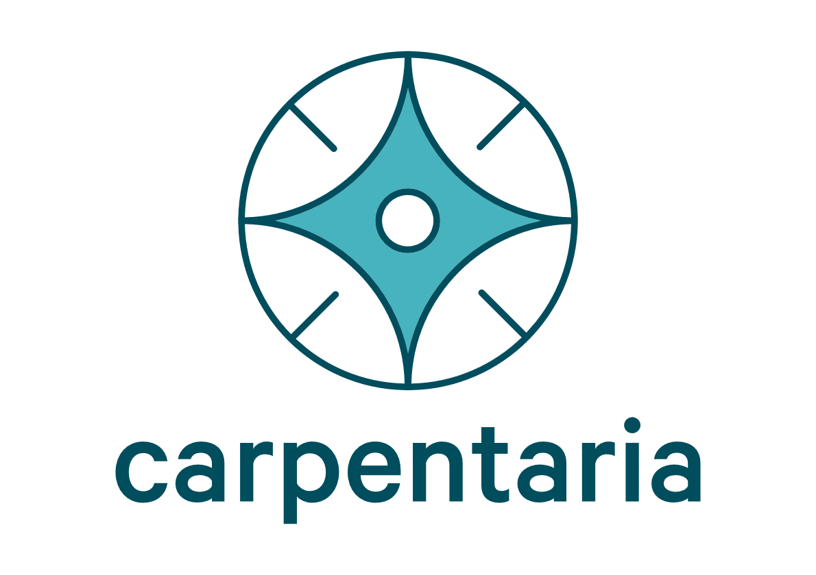

Nomination questions
How has the nominee introduced innovative solutions or approaches that enable greater access, participation, and independence of people with disability? *
Please write no more than 250 words.
What key features make this work innovative? *
Please write no more than 250 words.
How does the innovation respond to a challenge being experienced by people with disability? *
Please write no more than 250 words.
What positive impact has this innovation had on the lives of people with disability, their families and carers? *
Please write no more than 250 words.
Please explain how people with disability were involved in shaping the innovation. *
For example, through co-design, consultation, or feedback. Please write no more than 250 words.
Is there anything else you would like us to know about the nominee that supports your nomination? *
Please write no more than 250 words.
In 25 words (2-3 sentences), please summarise your nomination, highlighting achievements and impacts made. *
The summary will be used for all media purposes and onstage presentation at the Awards ceremony.

B-3 | Inclusive Communities Award
Award overview
This Award recognises an individual, team, business or organisation that has made a significant contribution to improving participation and inclusion of people with disability, their families and carers within the community.
It celebrates impactful inclusivity that is achieved through collaboration with people with disability, raising awareness and significantly improving access and integration across all aspects of community life, from public spaces, workplaces, and education, to events, services, and social activities.
Nominees may have demonstrated inclusivity by adapting services, programs, or approaches to promote inclusion and participation for all, or by actively enabling access to social, recreational, sporting, arts, cultural, or community activities.

This award is proudly sponsored by Somerville Community Services Inc.


Nomination questions
How is the nominee creating greater opportunity for people with disability to access and participate in the community, fostering independence and enhancing social connections? *
Please write no more than 250 words.
What mainstream services or aspects of community life have been impacted the most? *
Please write no more than 250 words.
How is the nominee promoting understanding, respect, and positive attitudes from the broader community? *
Please write no more than 250 words.
How impactful has the nominee’s work been on people with disability, their families, carers, or the wider community? *
Please write no more than 250 words.
How has the nominee actively involved people with disability in planning, decision-making, or leadership? *
Please write no more than 250 words.
Is there anything else you would like us to know about the nominee that supports your nomination? *
Please write no more than 250 words.
In 25 words (2-3 sentences), please summarise your nomination, highlighting achievements and impacts made. *
The summary will be used for all media purposes and onstage presentation at the Awards ceremony.

B-4 | Excellence in Service Provision

Award overview
This Award recognises the significant contribution of a disability sector organisation in providing supports, services and opportunities that are over and above best practice.
It highlights organisations leading the way and providing impactful services that are person-centred and respond to the diverse needs of the community.
Nominees may provide services in the following areas, but are not limited to:
- in-home supports that assist people with disability and their families to live independently and with dignity.
- therapy or capacity-building supports that help people with disability to develop skills and achieve their goals.

This award is proudly sponsored by Casuarina Square Shopping Centre.
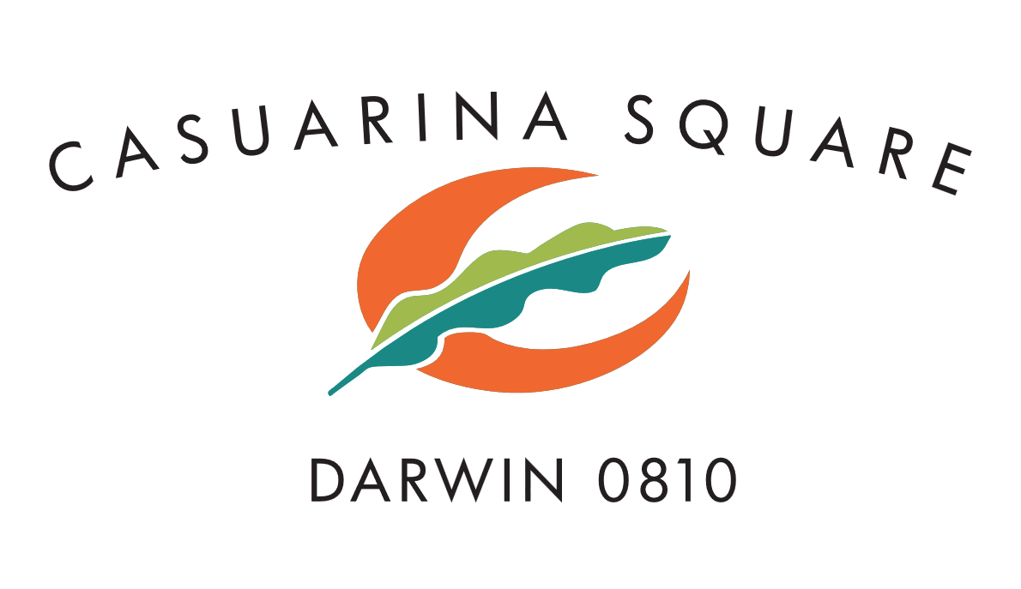

Nomination questions
What services, programs, or supports does the organisation provide for people with disability in the Northern Territory and what needs do they address? *
Please write no more than 250 words.
How has the organisation made an outstanding contribution to the disability sector and what meaningful impact has it made? *
Please write no more than 250 words.
How does the organisation support people with disability to build skills, independence, and exercise choice and control? *
Please write no more than 250 words.
How does the organisation ensure the services it delivers are safe, respectful, and responsive to individual needs? What are its safeguard policies and practices? *
Please write no more than 250 words.
How are people with disability involved in guiding practice, service expectations and outcomes? *
This could be through co-design of quality frameworks, processes or systems, or people with disability holding leadership and/or governance positions.
Please write no more than 250 words.
Is there anything else you would like us to know about the nominee that supports your nomination? *
Please write no more than 250 words.
In 25 words (2-3 sentences), please summarise your nomination, highlighting achievements and impacts made. *
The summary will be used for all media purposes and onstage presentation at the Awards ceremony.

B-5 | Excellence in Support

Award overview
This Award recognises the outstanding contribution of an individual in providing disability supports, services and opportunities over and above the needs of the people with disability they support.
It celebrates someone who demonstrates dedication, compassion, and skill in providing person-centred support and highlights the difference one person can make in fostering independence and supporting people with disability to live the life they choose.
Nominees may provide support in the following areas, but are not limited to:
- in-home supports that assist people with disability and their families to live independently and with dignity.
- therapy or capacity-building supports that help people with disability to develop skills and achieve their goals.

This award is proudly sponsored by HPA Incorporated.


Nomination questions
What role does the nominee play in supporting people with disability and in what setting? *
For example, in the community, workplace, family, or service setting.
Please write no more than 250 words.
How does the nominee support people with disability to exercise choice and control in their lives? *
Please write no more than 250 words.
Provide examples of how they actively involve people with disability in decisions about their support and services, including goal-setting. *
Please write no more than 250 words.
Provide examples of how their support has improved independence, wellbeing, participation, or inclusion. *
Please write no more than 250 words.
How do they adapt services, approaches, or activities to meet the unique needs of the people they support? *
Please write no more than 250 words.
Is there anything else you would like us to know about the nominee that supports your nomination? *
Please write no more than 250 words.
In 25 words (2-3 sentences), please summarise your nomination, highlighting achievements and impacts made. *
The summary will be used for all media purposes and onstage presentation at the Awards ceremony.

B-6 | Excellence in Education and Employment

Award overview
This Award recognises an outstanding individual, team, organisation or business that employs or supports people with disability to access education, training, or employment settings.
It celebrates the significant work and continued commitment of the nominees in creating meaningful pathways for people with disability to learn, develop skills, and participate fully in school, vocational training, or the workplace, empowering them to thrive.
Nominees may have demonstrated excellence in the following areas, but are not limited to:
- Supporting people with disability to gain, maintain, or progress in employment.
- Making workplaces more inclusive, accessible, and welcoming.
- Helping people with disability access education, training, or skill-building opportunities.
- Acting as a mentor, coach, or role model to support learning, growth, and development.


This award is proudly sponsored by Office of the Commissioner for Public Employment.

Nomination questions
What role does the nominee play in supporting people with disability in education, training, or employment? *
Please write no more than 250 words.
How does the nominee help people with disability to access and thrive in their chosen education, training, or employment setting? *
Please write no more than 250 words.
Provide examples of tailored supports, reasonable adjustments, or initiatives that have promoted inclusive, welcoming environments that encourage and support participation. *
Please write no more than 250 words.
How does the nominee demonstrate innovation, creativity, or best practice in education or employment supports for people with disability? *
Please write no more than 250 words.
What measurable or observable positive outcomes have been achieved for people with disability? *
For example, increased participation, employment retention, skill development, or personal growth.
Please write no more than 250 words.
Is there anything else you would like us to know about the nominee that supports your nomination? *
Please write no more than 250 words.
In 25 words (2-3 sentences), please summarise your nomination, highlighting achievements and impacts made. *
The summary will be used for all media purposes and onstage presentation at the Awards ceremony.

Part C – Additional information
Referee details
Please provide details for an external referee that can provide a reference and endorse the nomination.
Mr / Ms / Mrs / Mx / Miss / Master / Other:
Referee first name: * |  |  |  |  |  | Referee surname: *
Referee phone: * |  |  |  |  |  | Email: *
Referee relationship to nominee: *
Supporting information (optional)
Please select all types of supporting information to be submitted to OfficeofDisability.DPSC@nt.gov.au.
Submissions will be used to verify information provided in the Nomination Form. You can submit up to 5 files. More information can be found in the 2026 Nomination Guide at https://dpsc.nt.gov.au/ntdia.
☐ | Written testimonies |  |  |  |  |  | ☐ | Digital works (website, blog, videos, etc)
☐ | Videos or audio testimonies |  |  |  |  |  | ☐ | Evaluation or survey results
☐ | Photos of activities or initiatives that show work or impact |  |  |  |  |  | ☐ | Finalist or winner certificate from another Awards program
☐ | News stories |  |  |  |  |  | ☐ | No supporting information or documentation
☐ | Other informal supporting information:

Part D – Declaration and checklist
Declaration*
I declare:
- the information provided in this Nomination Form to be true and correct; and
- I have read the 2026 Nomination Guide including the Awards terms and conditions.
Signature: *
Full name: * |  |  |  |  |  |  |  |  | Date: *
Checklist
When submitting your Nomination Form please ensure the following:
☐ | All questions are answered in the relevant Award category section B1-B6
☐ | All contact details are completed and correct
☐ | Supporting information is attached (if applicable)
☐ | Nomination has been endorsed by the nominee
☐ | Nomination Form is emailed to OfficeofDisability.DPSC@nt.gov.au by Sunday 28 June 2026

Collection notice
We have collected your personal information which will be handled in accordance with the Northern Territory Information Act 2002. Your personal information is not required to be provided, however, if you do not, we may not be able to accept your nomination.
For more information on how we handle your personal information, please refer to the Awards Terms and conditions including the information and privacy policy in the 2026 Nomination Guide.

How to submit
Email your completed form and supporting information (if applicable) to OfficeofDisability.DPSC@nt.gov.au
Submissions must be received by the Office of Disability by Sunday 28 June 2026.
Nominations received after the closing date will not be accepted.

Contact
For more information, visit the Awards webpage: https://dpsc.nt.gov.au/ntdia

Should you have any questions about the Awards, contact the Office of Disability:
Phone: 08 8999 2809
Email: OfficeofDisability.DPSC@nt.gov.au
Address: 356-366 Bagot Road, Millner NT 0810
Postal Address: GPO Box 3970, Darwin NT 0801

  - End of form

